Lab - PC Setup for Workshop (Instructor Version)

**Instructor Note**: Red font color or gray highlights indicate text that appears in the instructor copy only.

1. Objectives

In this lab, you will complete the following objectives in order to prepare your computer for the course:

Part 1: Install and Verify Python

Part 2: Install Postman

Part 3: Install JSONView

1. Computer Requirements

* Windows, MAC, or Linux computer
* Google account
* Chrome browser
* Script and data files (download from page 1.0.1.2 in course)

1. Install and Verify Python

Complete the following steps to install and verify Python.

* + 1. Download and install Python.

Go to <https://www.python.org/downloads> and download the most recent version of Python 3.

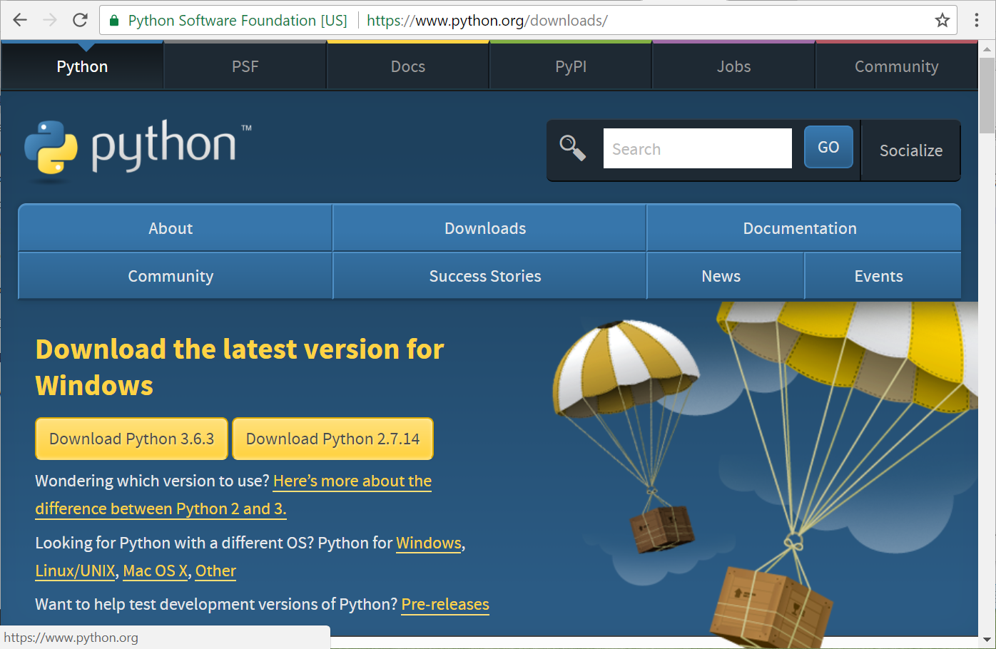

When installing, make sure you check the "Add Python 3.6 to Path" checkbox.

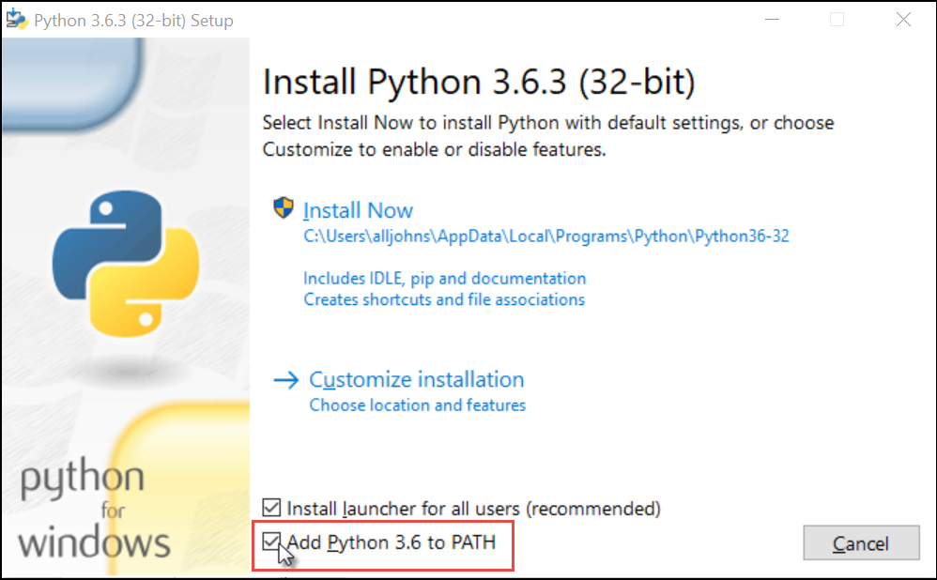

When setup finishes, click the "Disable path length limit" if this option is available for your installation

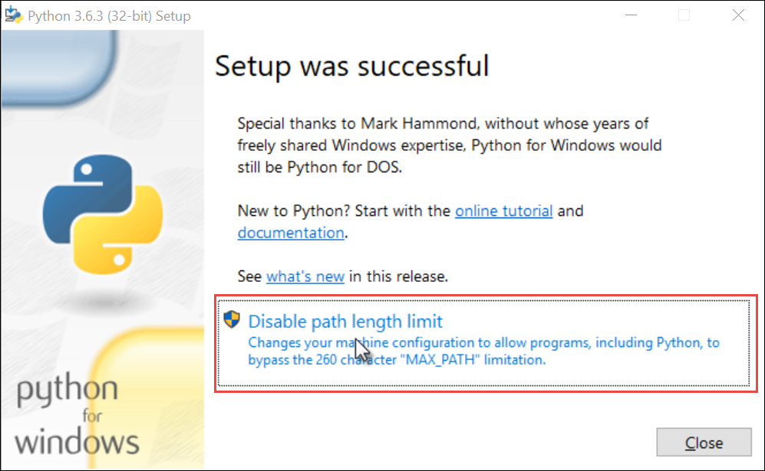

* + 1. Test your Python installation.

For the Windows OS, open a command prompt and enter the command **python**. The interactive interpreter should open. Type **quit()** to exit the Python interactive interpreter.

C:\> **python**

Python 3.6.3 (v3.6.3:2c5fed8, Oct 3 2017, 17:26:49) [MSC v.1900 32 bit (Intel)] on win32

Type "help", "copyright", "credits" or "license" for more information.

>>> **quit()**

C:\>

For the Mac or Linux OS, open a command prompt and enter the command **python3**. Type **quit()** to exit the Python interactive interpreter.

$ **python3**

Python 3.5.2 (default, Oct 3 2017, 17:48:00)

[GCC 5.4.0 20160609] on linux

Type "help", "copyright", "credits" or "license" for more information.

>>> **quit()**

$

* + 1. Verify that you can open IDLE.

For the Windows OS, open IDLE from the Programs menu: **Start > Python 3.6 > IDLE (Python 3.6 32-bit)**.

For the Mac or Linux OS, open a command prompt and enter the command **idle3**.

The IDLE shell should open.

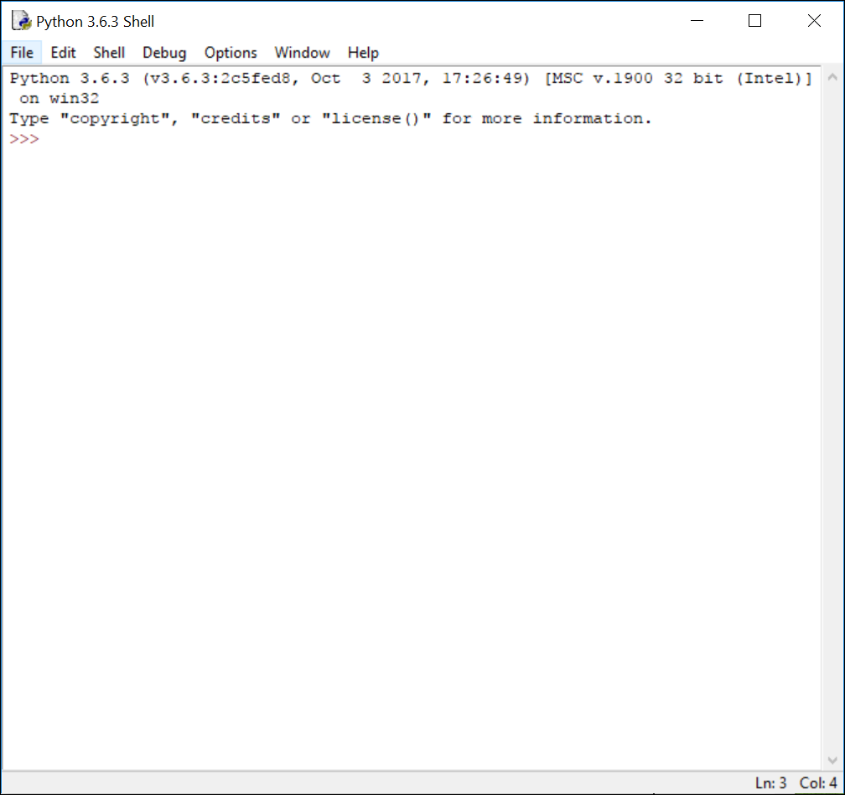

* + 1. Install Python modules that will be used in the course.

The default Python installation comes with all the standard modules that most programmers would need to create applications. However, there are many more modules available that extend the functionality of Python. To keep the initial installation of Python small, these modules are not including in the default package.

Returning to your command prompt window, use Python Package Index (accessed with the pip command) to download the modules requests and tabulate, as shown for Windows in Example 3. For Linux and Mac, use **pip3 install** *module_name*.

C:\> pip install requests

Collecting module

Downloading module-0.2.1.tar.gz

Collecting requests

Downloading requests-2.18.4-py2.py3-none-any.whl (88kB)

100% |████████████████████████████████| 92kB 217kB/s

Collecting idna<2.7,>=2.5 (from requests)

Downloading idna-2.6-py2.py3-none-any.whl (56kB)

100% |████████████████████████████████| 61kB 1.2MB/s

Collecting certifi>=2017.4.17 (from requests)

Downloading certifi-2017.11.5-py2.py3-none-any.whl (330kB)

100% |████████████████████████████████| 337kB 139kB/s

Collecting chardet<3.1.0,>=3.0.2 (from requests)

Downloading chardet-3.0.4-py2.py3-none-any.whl (133kB)

100% |████████████████████████████████| 143kB 782kB/s

Collecting urllib3<1.23,>=1.21.1 (from requests)

Downloading urllib3-1.22-py2.py3-none-any.whl (132kB)

100% |████████████████████████████████| 133kB 1.2MB/s

Installing collected packages: module, idna, certifi, chardet, urllib3, requests

Running setup.py install for module ... done

Successfully installed certifi-2017.11.5 chardet-3.0.4 idna-2.6 module-0.2.1 requests-2.18.4 urllib3-1.22

C:\> pip install tabulate

Collecting module

Collecting tabulate

Downloading tabulate-0.8.1.tar.gz (45kB)

100% |████████████████████████████████| 51kB 71kB/s

Installing collected packages: tabulate

Running setup.py install for tabulate ... done

Successfully installed tabulate-0.8.1

C:\>

1. Install Postman

Postman is an application that you will use in this course to make HTTP API requests.

* + 1. Download the Postman application.

Postman is available as an application for Windows, Mac, and Linux operating systems. To install Postman, go to the apps page at <https://www.getpostman.com/apps> and click Download for your OS.

* + 1. Sign up to use Postman or choose to create an account at another time.
    2. Verify that the Postman application is installed.

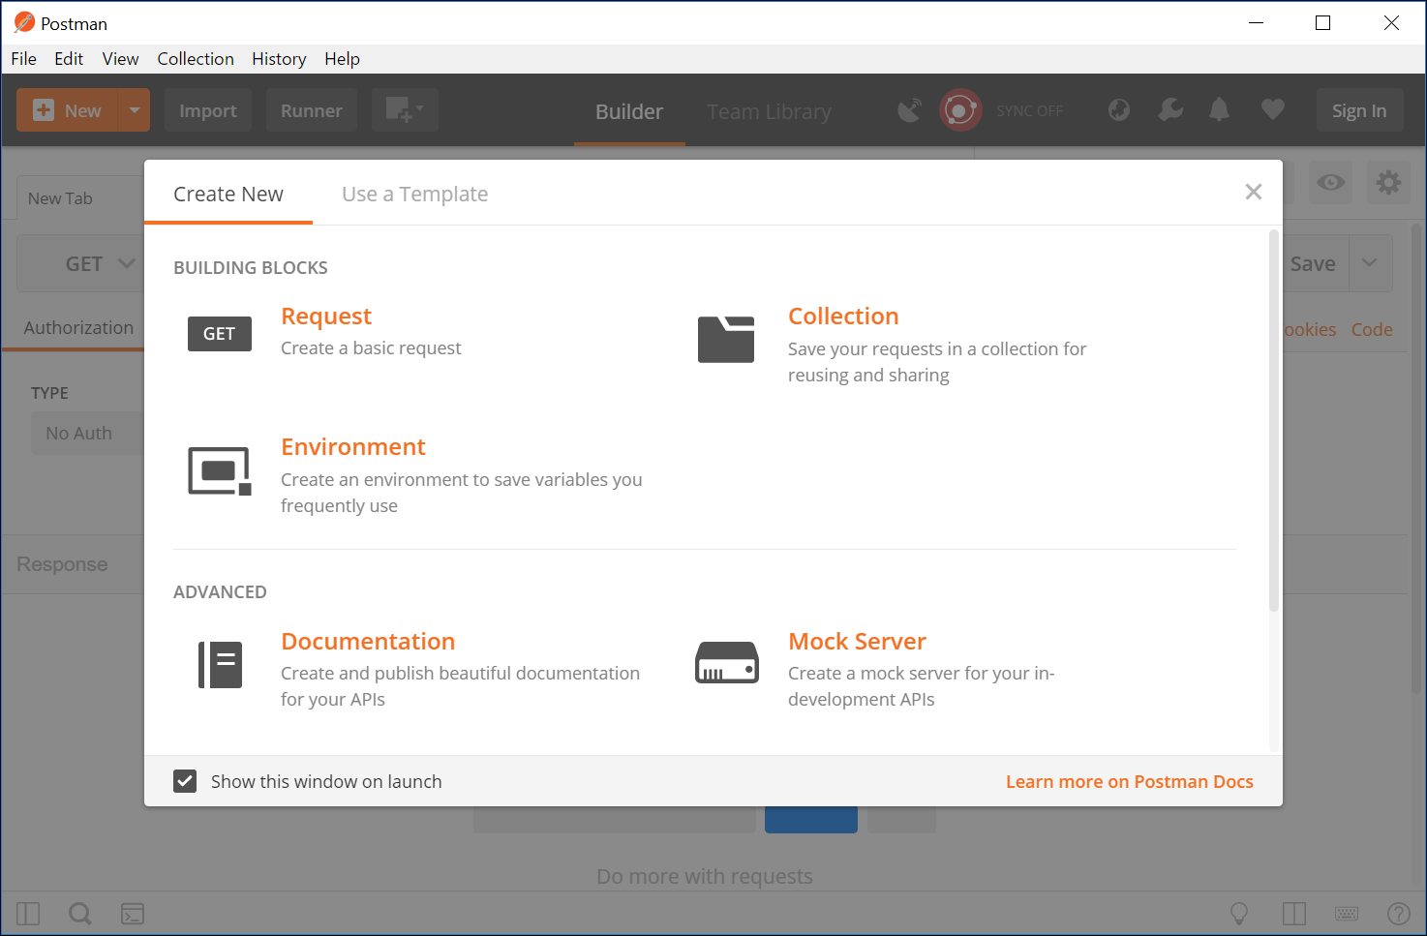

1. Install JSONView

JSONView is a Chrome extension that you will use in this course to better view JSON data.

* + 1. Install the JSONView Chrome extension.

Click [here](https://chrome.google.com/webstore/detail/jsonview/chklaanhfefbnpoihckbnefhakgolnmc) to access the JSONView extension and add it to Chrome. After installation, you should see the JSONView icon in the top right corner of your Chrome browser.

**Note**: If the link does not work, search for “Chrome JSONView extension” to locate it.

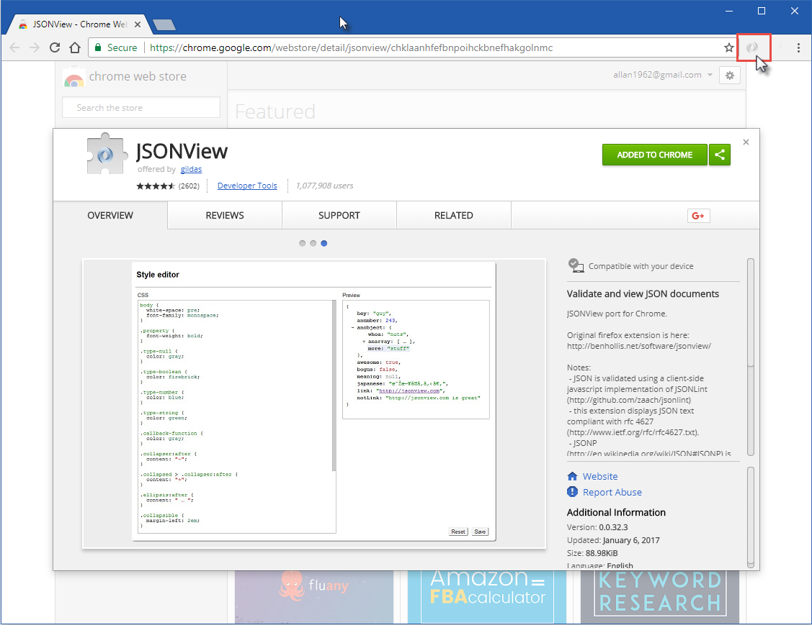

* + 1. Test the JSONView extension.

Use the Google Map Geocoding link below verify that your JSONView extension is working properly. You should be able to collapse and expand sections of the JSON data.

<http://maps.googleapis.com/maps/api/geocode/json?address=sanjose>